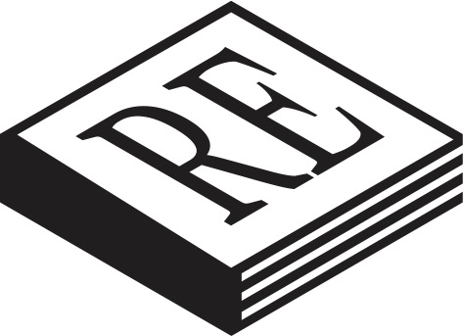
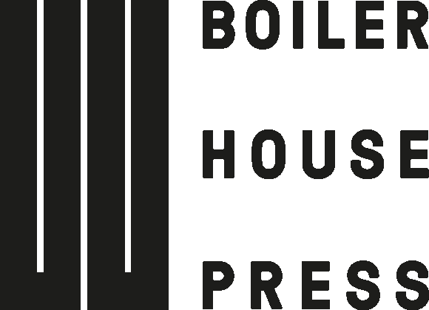

For Immediate Release

Boiler House Press is proud to announce the launch of a new initiative to bring unfairly forgotten books of exceptional merit and resounding relevance to the attention of today’s engaged readers: Recovered Books, launching this November 2021, with its first two publications: Gentleman Overboard by Herbert Clyde Lewis and What Katy Did by Susan Coolidge.

Inspired by the passion of Brad Bigelow, founder of www.neglectedbooks.com and a long-time campaigner for the rediscovery of books and writers lost or abandoned in the tides of changing tastes, Recovered Books aims to meet three essential goals in the service of the interested reader:

- To bring forgotten and often difficult to find books back to print for a new generation of readers.

- To introduce readers and researchers to these under-appreciated writers and encourage them to expand their outdated notions of the canon.

- To present exquisitely designed books that are – above all – exciting and interesting to read.

Recovered Books isn’t just about restoring neglected books: it’s about offering remarkable and memorable reading experiences. Gentleman Overboard by Herbert Clyde Lewis is one such experience: it is a wonderfully tragi-comic parable of isolation and abandonment which, despite becoming something of an international phenomenon since it was first featured on Neglected Books over a decade ago, achieving critical and popular success with translations into Dutch, Hebrew and Spanish, is still essentially unknown in English. Now, Recovered Books brings this work — “a little pearl,” as one Spanish critic called it — back to entertain English language readers. This edition includes an introduction by George Szirtes, poet and winner of the James Tait Black Prize for The Photographer at Sixteen, and an afterword by series editor, Brad Bigelow.

What Katy Did by Susan Coolidge is a 19th Century American children’s classic. It has been ‘Recovered’ in a different sense, having been restored through the work of a unique undergraduate project at the University of East Anglia. UEA students contributed the introduction and guided the book’s design and presentation with the worthy goal of contextualising the story for the modern younger reader and of increased accessibility for dyslexic readers and those managing similar challenges.
Gentleman Overboard and What Katy Did will be published on 30 November, 2021.

/ends

Notes for editors

- Since its founding in 2017, at the University of East Anglia, and despite its relatively tiny size and resources, Boiler House Press has developed a global reputation for consistently publishing works of innovative thinking and bold creativity.

- Recent hit titles include Ben Pester’s Am I In The Right Place?, Sophie Robinson’s Rabbit, and This Paradise by Ruby Cowling, which was shortlisted for the Edge Hill Short Story Prize and the George Orwell Prize For Political Fiction.

- In June 2021, it relaunched the Beyond Criticism Editions series, inherited from Bloomsbury, and featuring fascinating genre-bending work by Ansgar Allen, Simon Palfrey and Ewan Fernie, among others.

- For comment, photos, or more information contact Boiler House Press at publishing@uea.ac.uk / 01603 593707

