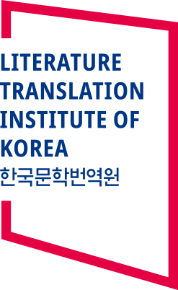
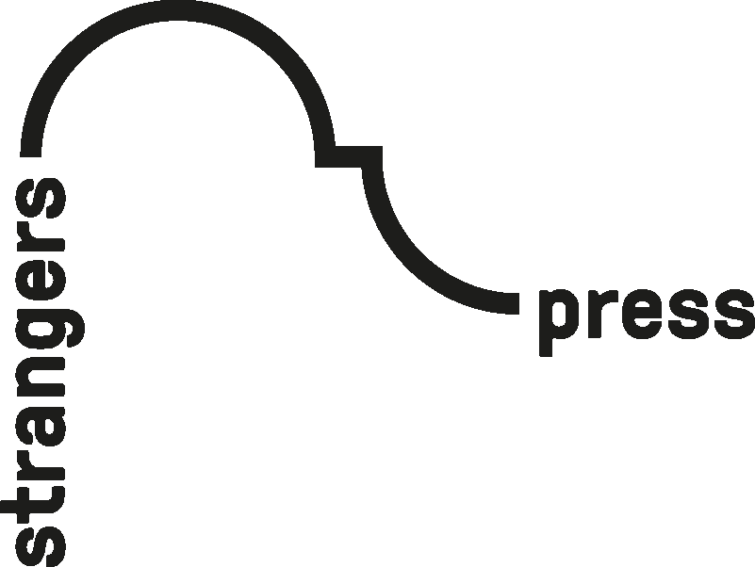
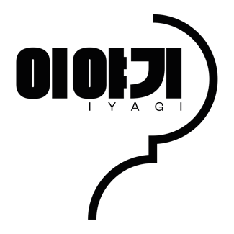
Strangers Press’ new KOREAN translation competition
// IYAGI 이야기 //
For Immediate Release
Strangers Press, based at the Interdisciplinary Institute for the Humanities (IIH), University of East Anglia (UEA), is excited to announce a new Korean translation competition for their upcoming collection, IYAGI (이야기: meaning ‘story’ or ‘talk’), to be released April 2022, supported by LTI Korea.

Like the hugely popular YEOYU before it, which featured authors such as Han Kang, winner of the International Booker Prize, Bae Suah, and Han Yujoo, IYAGI will again comprise eight exquisitely designed short story chapbooks featuring eight of the most exciting writers working in Korean today, selected by series editor, Anton Hur, and translated by expert translators from around the world.

This competition offers the chance for one early-career translator to be among them. It is open only to translators as yet unpublished in book form, though anthologies and magazines, in print and online, is OK.

Entrants will be required to submit a 1,500-word translation of a set excerpt of the story ‘복원되지 못한 것들을 위하여’ by 박완서 (‘What Cannot Be Restored’ by Park Wanseo) by 00:00AM (GMT), August 16th, 2021. The text and entry portal, along with further information, can be found here: www.strangers.press/iyagi-korean-translation-competition.

The winner will be announced on August 31st and will win a full grant from LTI Korea to translate the text in full, paid at a professional rate, and edited by Anton Hur and Strangers Press. It will then be included in the exciting new IYAGI series, soon to be announced in full, which will be publishing in April 2022. Good luck!
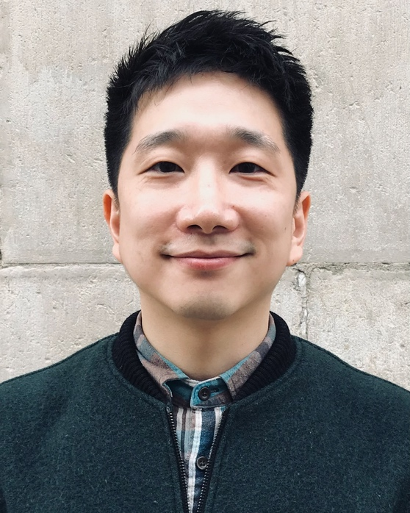
About The judges:

Anton Hur, is the translator of Bora Chung's Cursed Bunny (Honford Star) and Sang Young Park's Love in the Big City (Grove, Tilted Axis). Who has also won the PEN Translates and PEN/Heim grants and was translator-in-residence at the National Centre for Writing and Queen's College University of Oxford. He currently resides in Seoul.

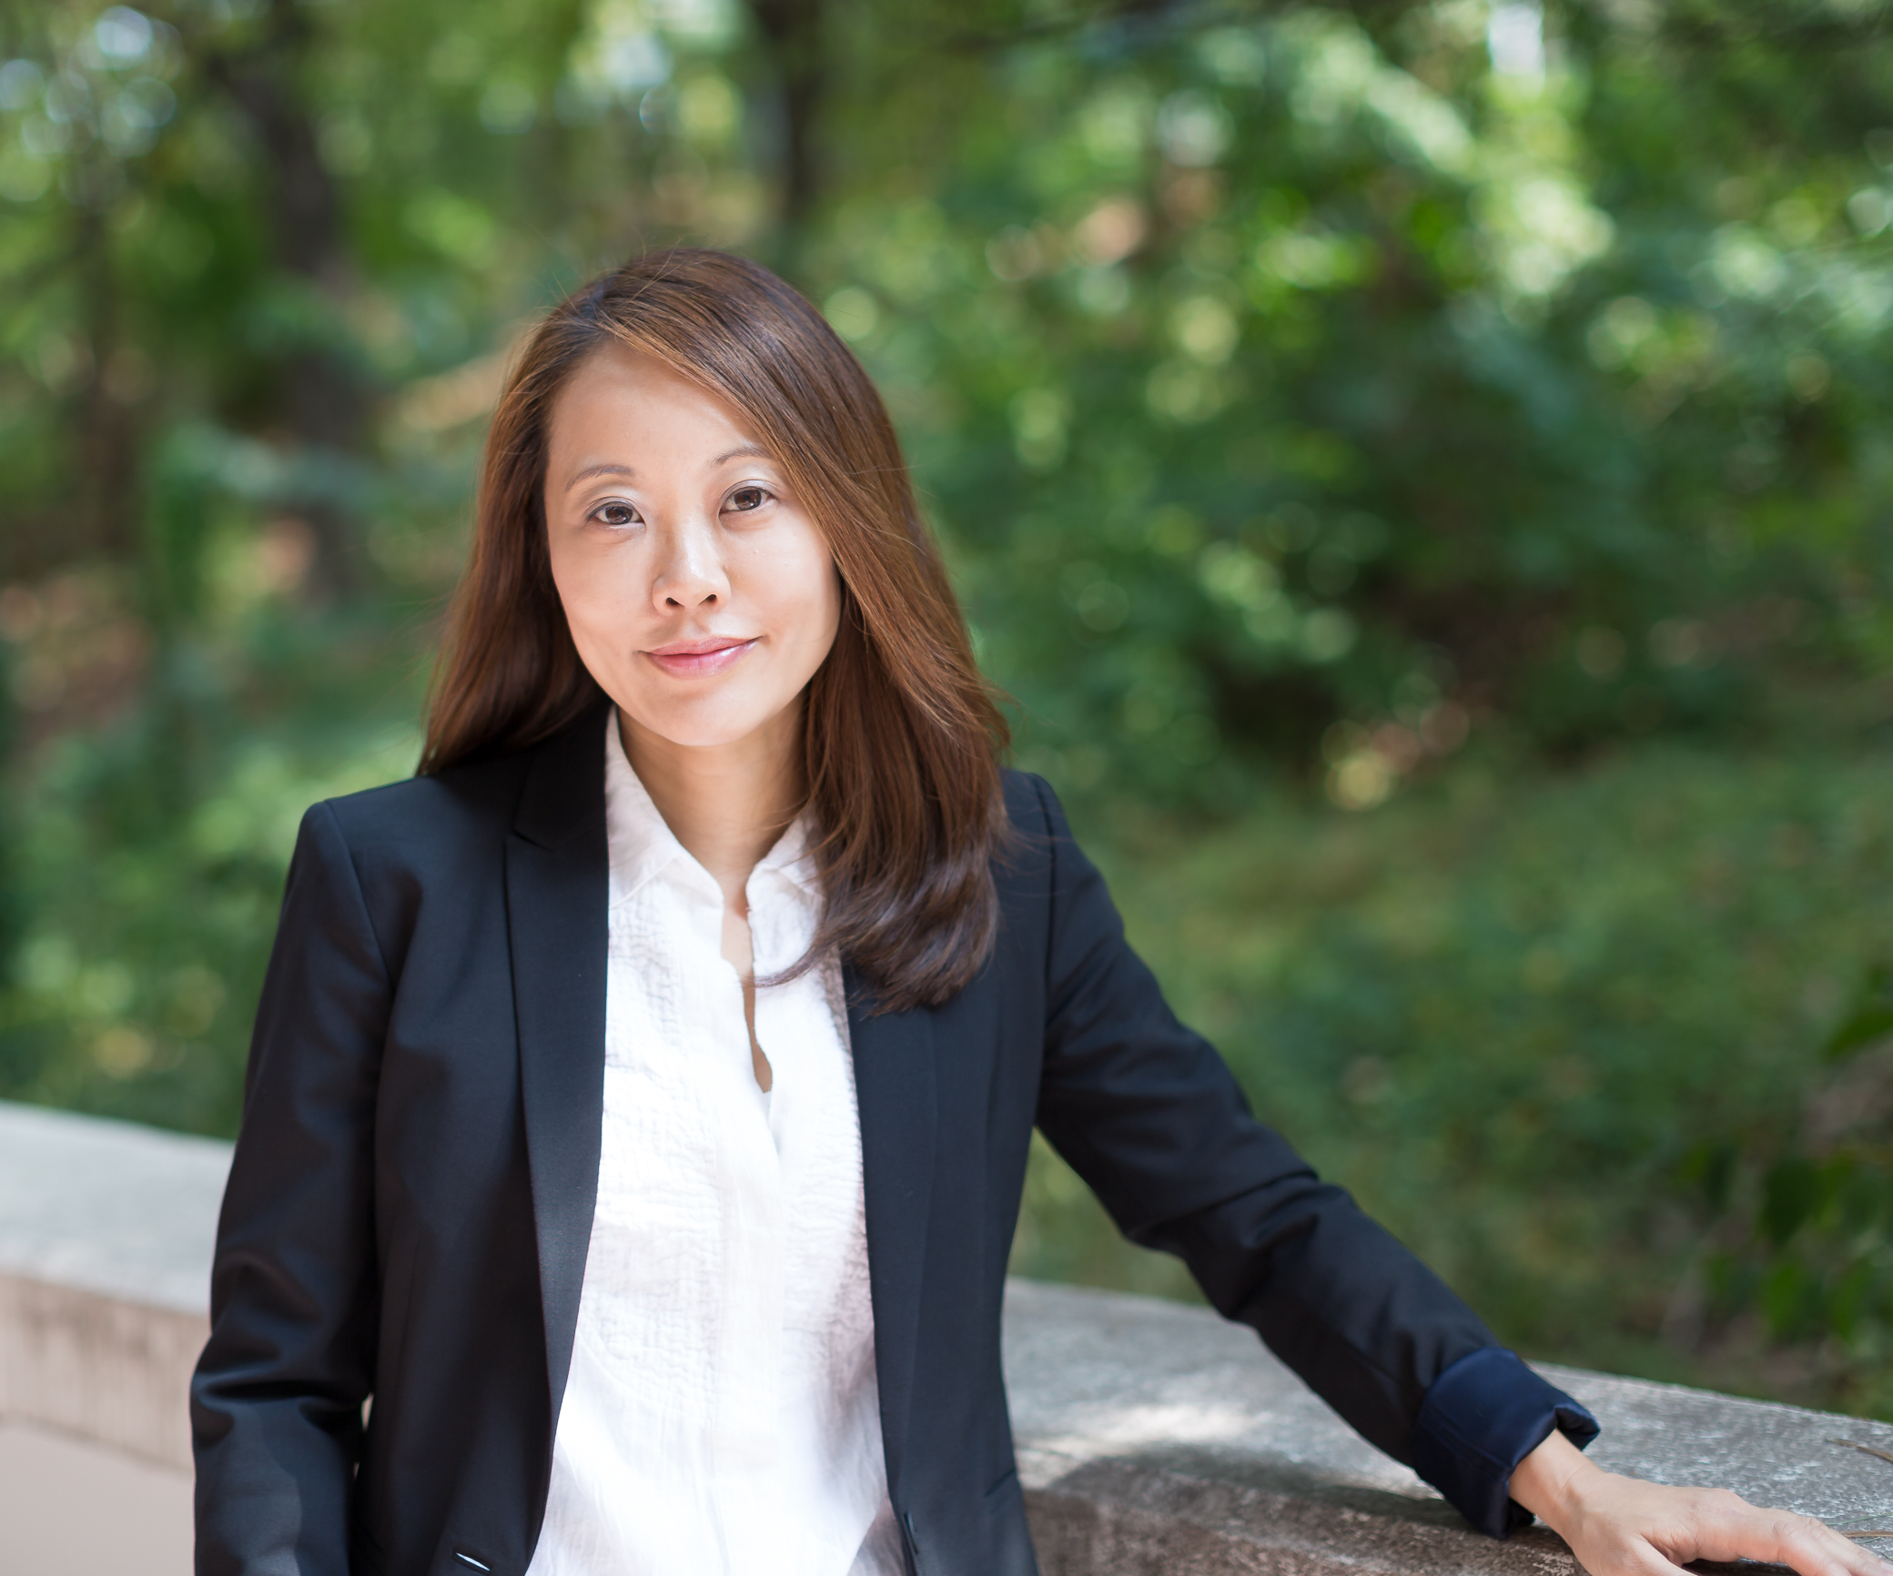
Krys Lee, the author of the story collection Drifting House and the novel How I Became a North Korean, and the translator of I Hear Your Voice and Diary of a Murderer: And Other Stories by Young-ha Kim. She received the Rome Prize in Literature, the Story Prize Spotlight Award, and the Honor Title in Adult Fiction Literature from the Asian/Pacific American Libraries Association, was a Granta New Voices writer, as well as a finalist for the Center for Fiction First Novel Prize and the BBC National Story Award. She currently teaches creative writing at Yonsei University, Underwood International College in Seoul, South Korea.
/Ends
Notes to Editors:

- Strangers Press were the publishers of the hugely successful KESHIKI series, which saw early publication in English of Japanese authors Aoko Matsuda, Nao-Cola Yamasaki, Misumi Kubo and Matsatugu Ono, alongside more established names such as Yoko Tawada.
- Strangers Press has since established a name for itself published exciting work in translation in creative and innovative ways
- In 2020, at the height of the pandemic, Strangers Press published VERZET, a series of stories translated from the dutch and featuring International Man Booker Prize winner Michele Hutchison
- Based in Norwich, UNESCO City of Literature, Strangers Press is dedicated to publishing the finest literature in translation in collaboration with the British Centre for Literary Translation, University of East Anglia, and The National Centre for Writing. We believe translation is a cultural exchange. https://www.strangers.press/
- This competition, and the IYAGI series more broadly, is supported by generous funding from LTI Korea: https://www.ltikorea.or.kr/en/main.do#introduction
- For comment, photos, or more information contact Strangers Press at publishing@uea.ac.uk / 01603 593707

